CS 255 Project Two
System Design Document
DriverPass System
Jesus Velasquez

UML Diagrams
The following diagrams translate DriverPass's business requirements into structural and behavioral views of the proposed system.

UML Use Case Diagram
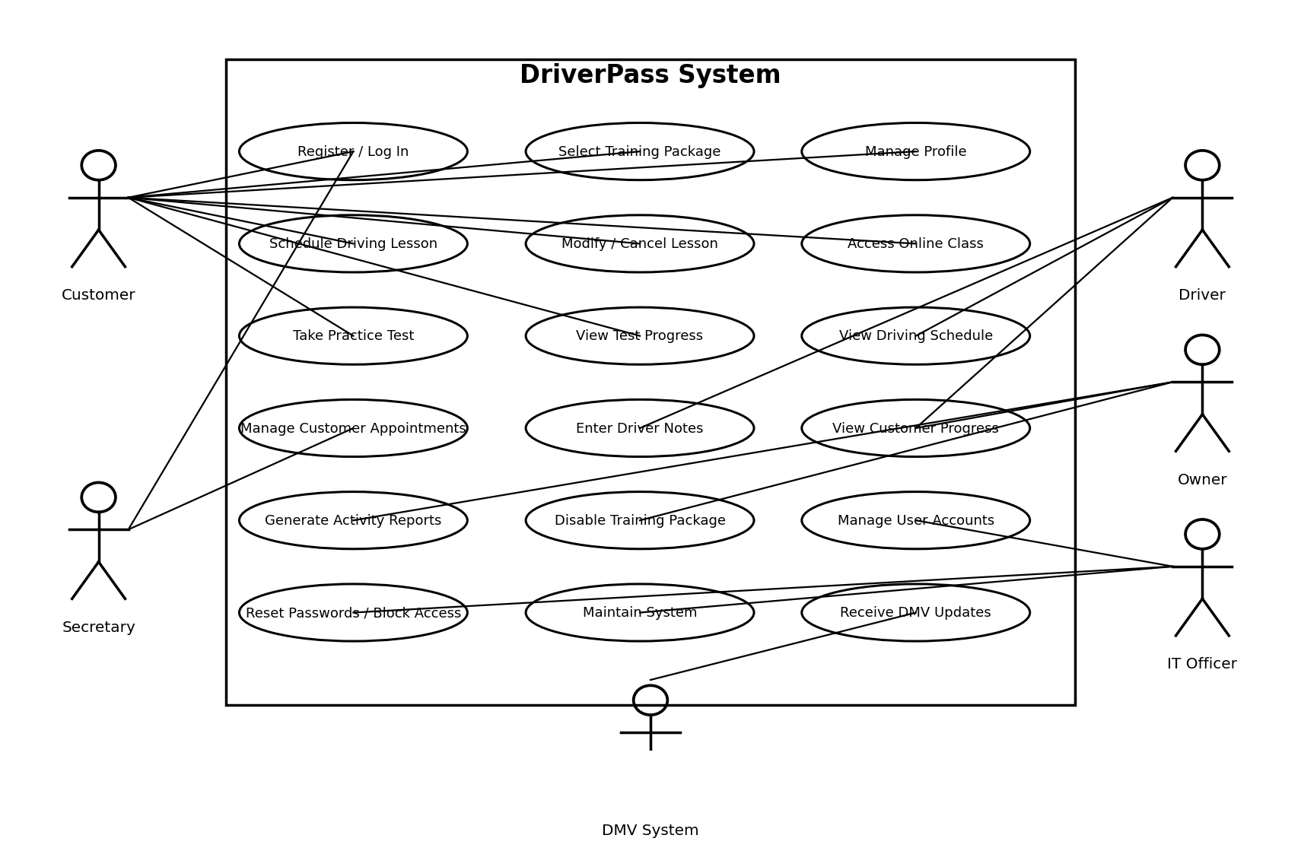
Figure 1. DriverPass system use case diagram.

UML Activity Diagram 1 - Schedule Driving Lesson
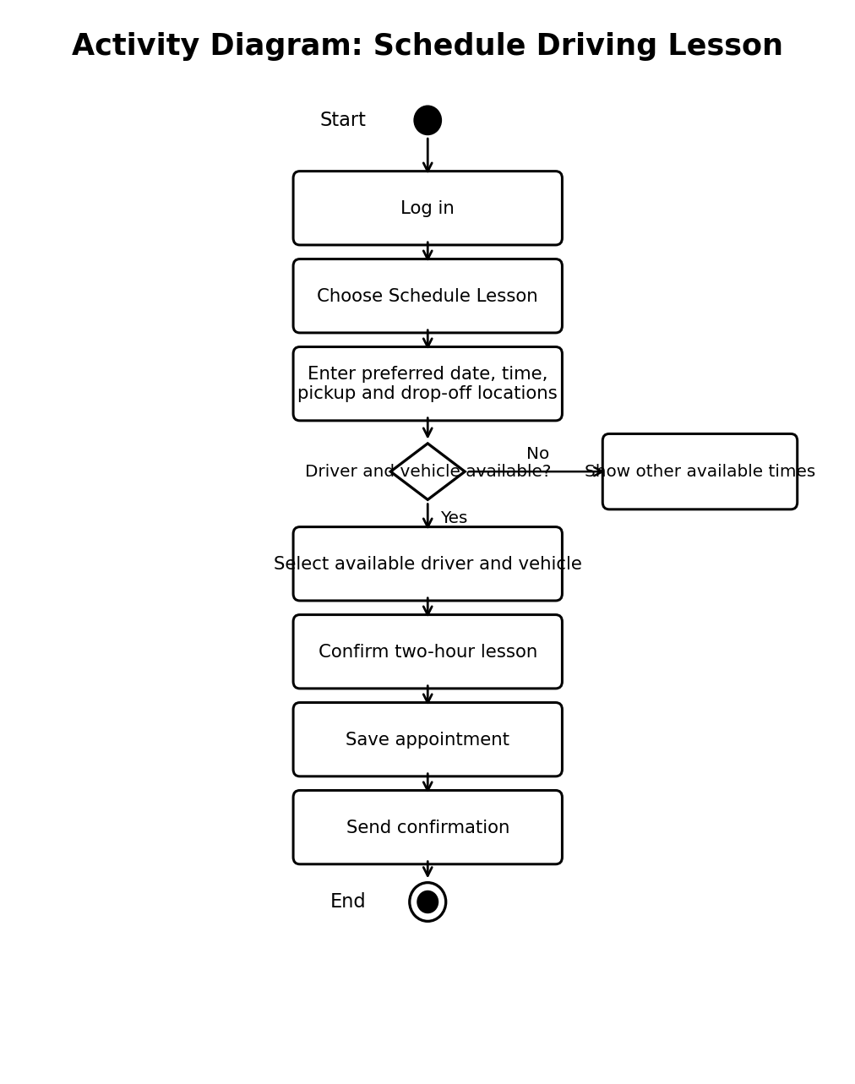
Figure 2. Activity flow for scheduling a driving lesson.

UML Activity Diagram 2 - Take Practice Test
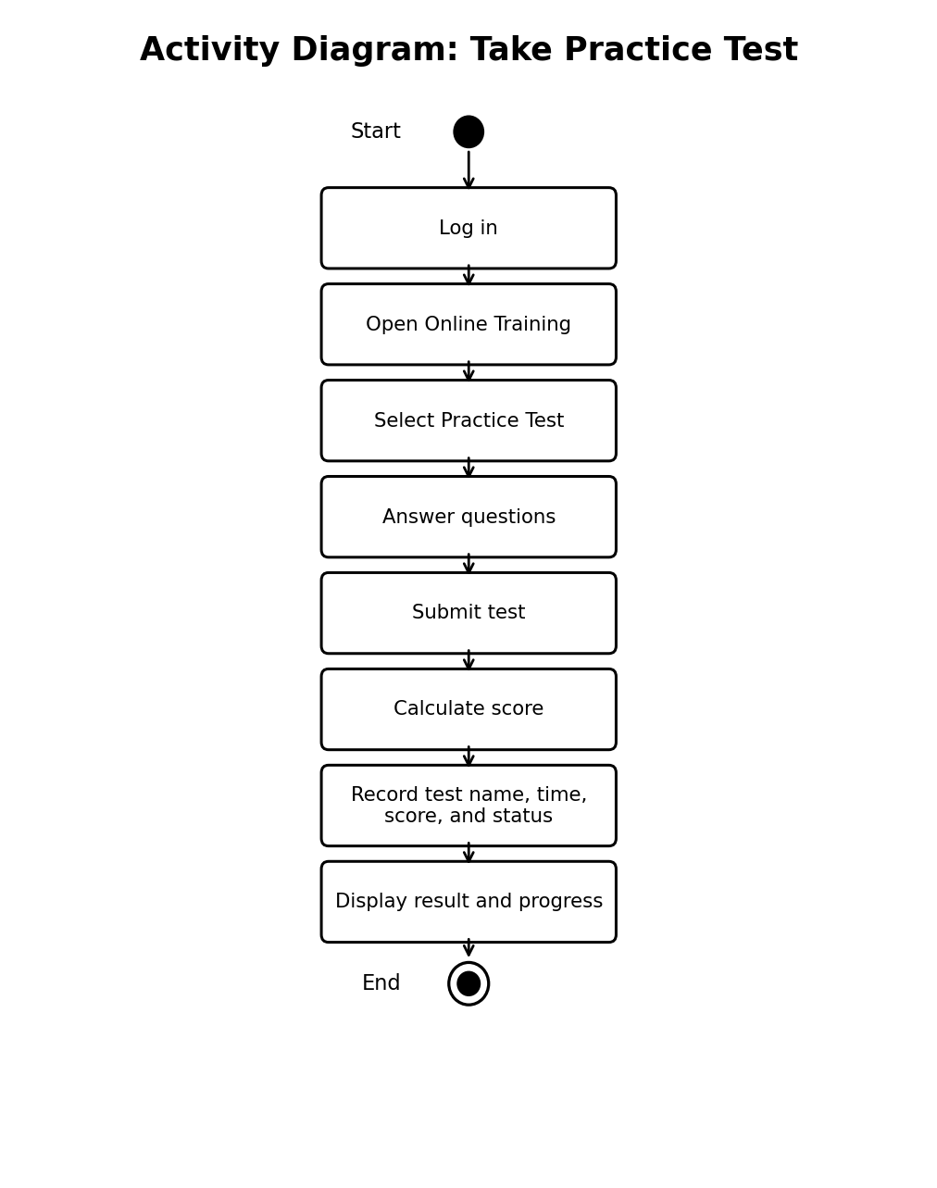
Figure 3. Activity flow for completing an online practice test.

UML Sequence Diagram - Schedule Driving Lesson
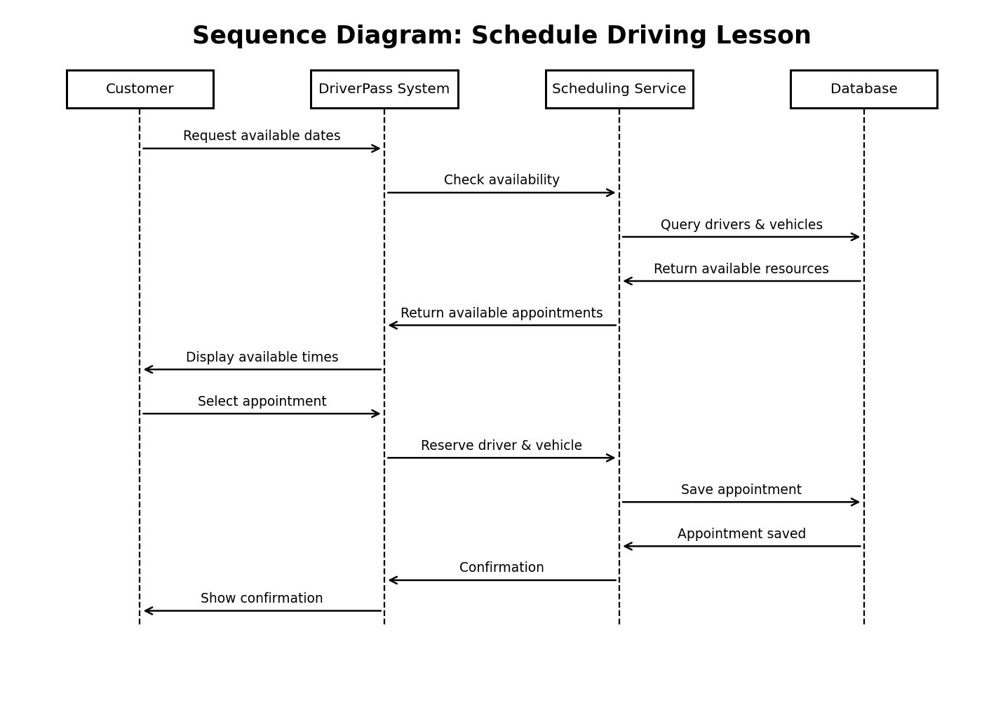
Figure 4. Sequence of interactions used to schedule a driving lesson.

UML Class Diagram
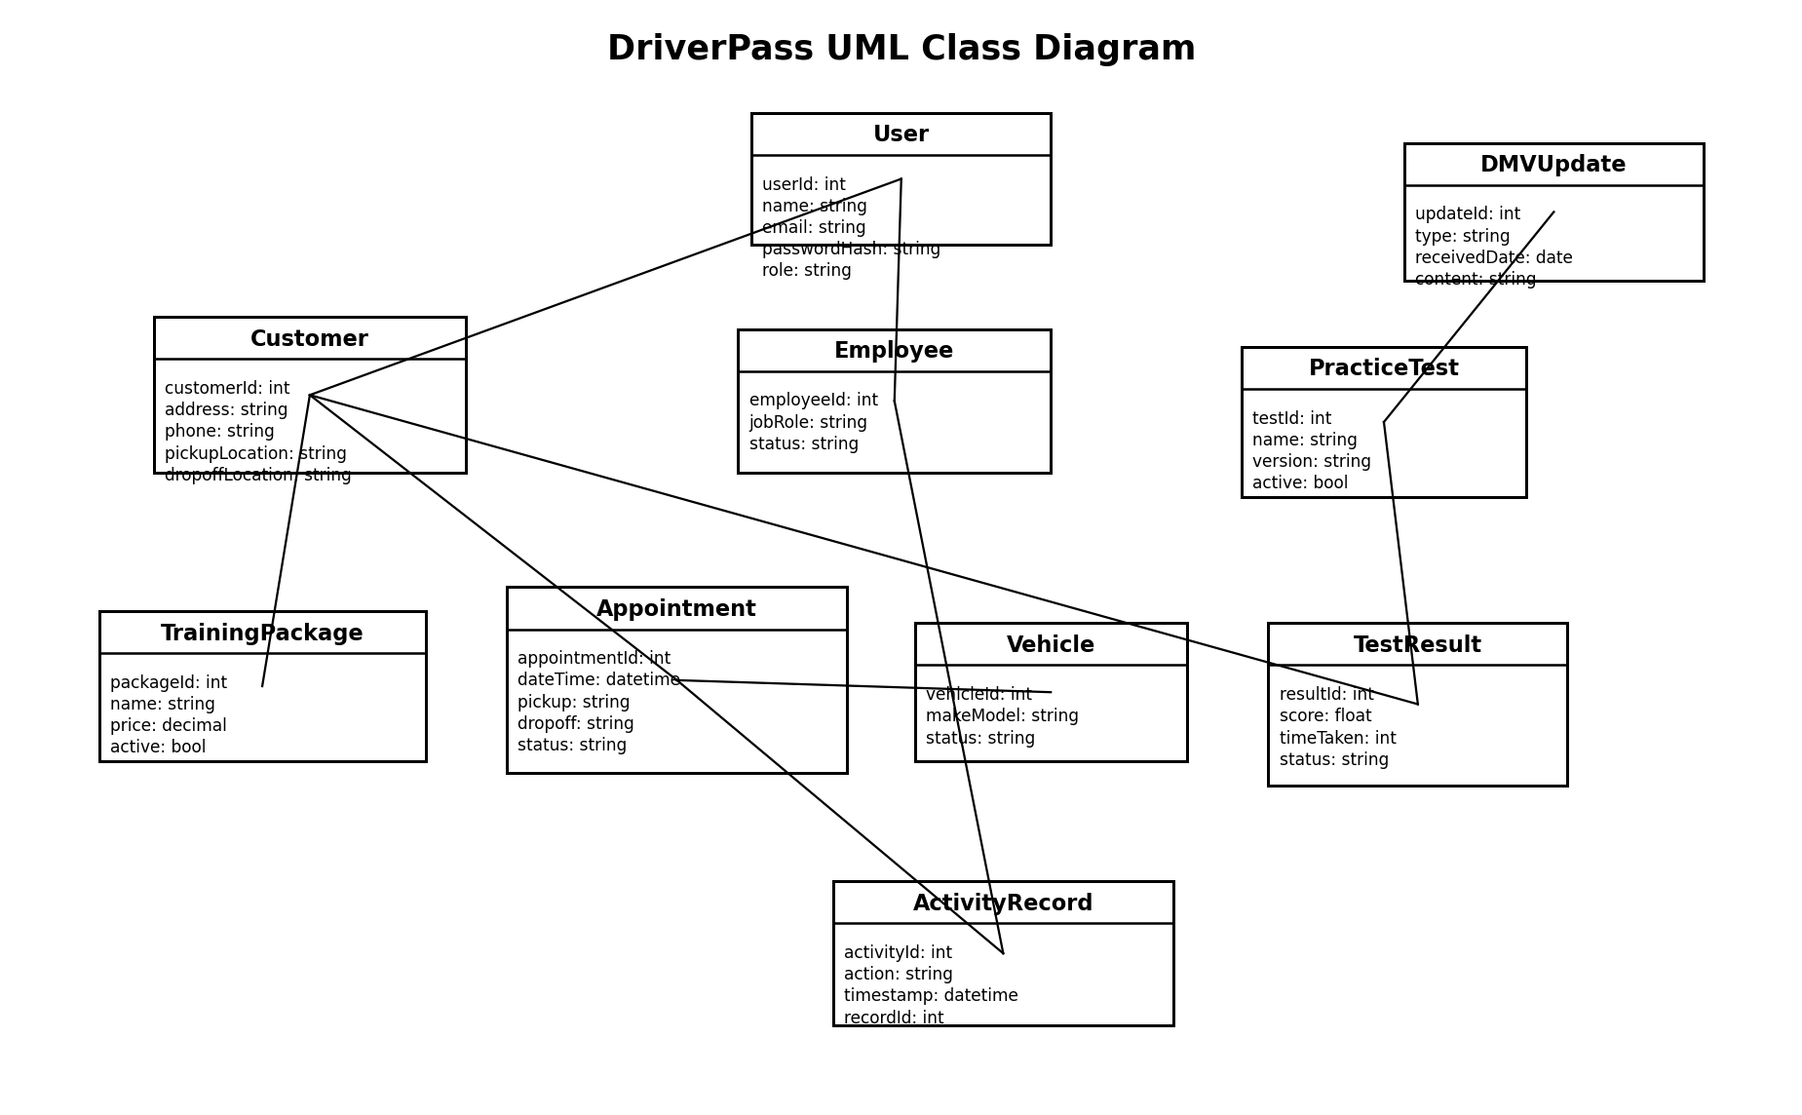
Figure 5. Core classes and attributes for the DriverPass system.

Technical Requirements
Hardware: DriverPass employees will need internet-connected desktop or laptop computers for office work. Drivers and customers should be able to use common computers, tablets, or mobile devices. Because the proposed system is cloud hosted, DriverPass does not need to maintain its own application or database servers on site.
Software: The system will be a web-based application that works through current common web browsers. The application will include a secure user interface, server-side application services, and a centralized relational database. Authorized users will also need the ability to download selected reports in a format that can be opened in spreadsheet software such as Excel.
Tools and Development: The development team should use a CASE tool such as Lucidchart for UML documentation, source-control tools for application code, a database management system for persistent records, and automated testing tools for login, scheduling, testing, reporting, and permission checks. The application should be designed so training packages, user accounts, and DMV-provided content can be updated without redesigning the entire system.
Infrastructure: The application and database should be hosted in a reliable cloud environment. The infrastructure must provide encrypted connections between users, the application, and the database; routine backups; recovery capability; monitoring; and enough capacity to support customers and employees accessing the system from different locations. Updates to records should require an internet connection so the system maintains one current version of its data.
Security and Access: Every user must authenticate before reaching protected functions. Permissions will be based on role so customers, the secretary, drivers, the owner, and the IT officer receive only the access required for their responsibilities. The IT officer must be able to reset passwords and block accounts. The system should also record important reservation changes so DriverPass can determine who created, modified, or canceled an appointment.
Data and Integration: The database must accurately associate every driving appointment with the correct customer, driver, vehicle, date, time, pickup location, and drop-off location. Practice-test records must store the test name, time taken, score, and status. The system must also receive DMV rule, policy, and practice-question updates and notify DriverPass when new information is available.

